The Therapy Centre UK Limited  102 Horsforth Avenue, Bridlington, East Yorkshire YO15 3DF  Tel/Fax: 01262 674801  Email: info@therapycentreuk.com  Website: www.therapycentreuk.com  REIKI MASTER TEACHER TRAINING |  |  |  |  | 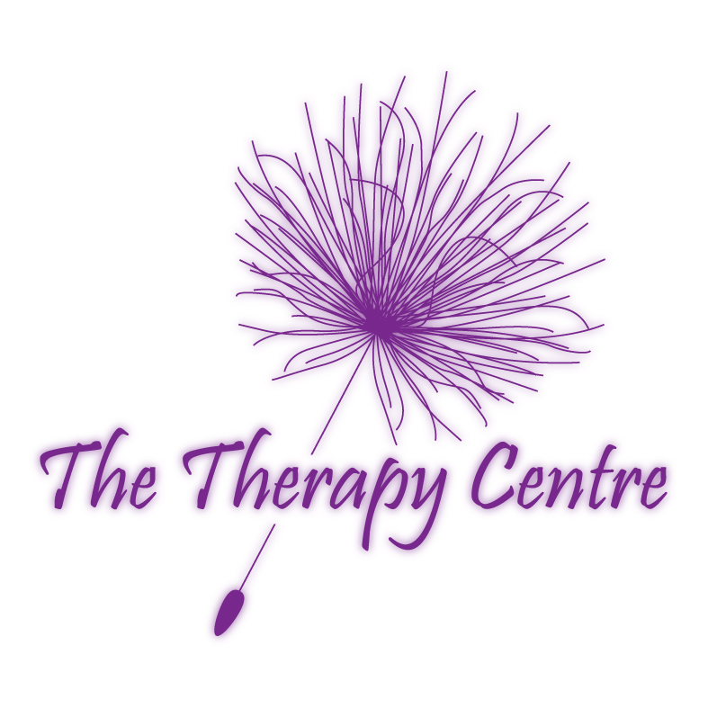
To ensure the course of your selection meets your needs, and that places are still available,
please contact the trainer or facilitator for further information.

Course Title: | REIKI MASTER TEACHER
Introduction: | Reiki is a powerful method of hands on healing and self-development that is easily learnt. It differs from other methods of healing in that it requires a series of attunements by a Reiki Master. You will be given a comprehensive manual on completion of your two days training.
Requirements: | Reiki l & II
Benefits: | This course introduces the use of the Master Symbol, the teaching of Reiki and the ability to pass on attunements to others. Two third degree attunements are received to empower the learner to become a Reiki Teacher Master by further strengthening their energy field, enhancing their Reiki channelling ability and by promoting further personal and spiritual development.
Syllabus: | - What is a Reiki Master Teacher?  - Dai Ko Myo – The Master Symbol  - Attunements  - First Degree Initiations  - Second Degree Initiations  - Lineage |  | - Gita – The Philosophy Of Karma  - Remote Viewing  - Manifestations and Miracles  - Psychic Surgery  - Mandalas
Certification: | Certificate of Attendance – Valid for insurance purposes.
Duration: | 2 Days
Group Size: | Maximum of 12 learners per course.
Venue: | The Therapy Centre UK Limited  102 Horsforth Avenue, Bridlington, East Yorkshire YO15 3DF
Trainer: | Lesley Cox – Reiki Master Teacher since June 1999, having trained for her masters with her teacher Sally Mynavati Sudevan from India whose mentor is Sai Baba.  Lesley is an experienced and qualified teacher possessing qualifications in Postgraduate Certificate In Education, BA (Hons) Applied Social Science and Business, Anatomy and Physiology, Diploma in Counselling, Reflexology, Touch For Health, Hopi Ear Candles and  Hot Stone Massage.
Payment: | Non-returnable deposit of £50 is required to ensure you a place on the course.  Course cost can be paid in instalments by prior arrangement.  Payment to be paid in full four weeks prior to course date.
2018 Reiki Master Teacher Schedule

Dates |  | Times |  | Cost
Saturday 8th & Sunday 9th September 18 |  | 9.30 a.m. – 5.30 p.m. |  | £500.00

