The Therapy Centre UK Limited  102 Horsforth Avenue, Bridlington, East Yorkshire YO15 3DF  Tel/Fax: 01262 674801  Email: info@therapycentreuk.com  Website: www.therapycentreuk.com  REIKI lI TRAINING |  |  |  |  | 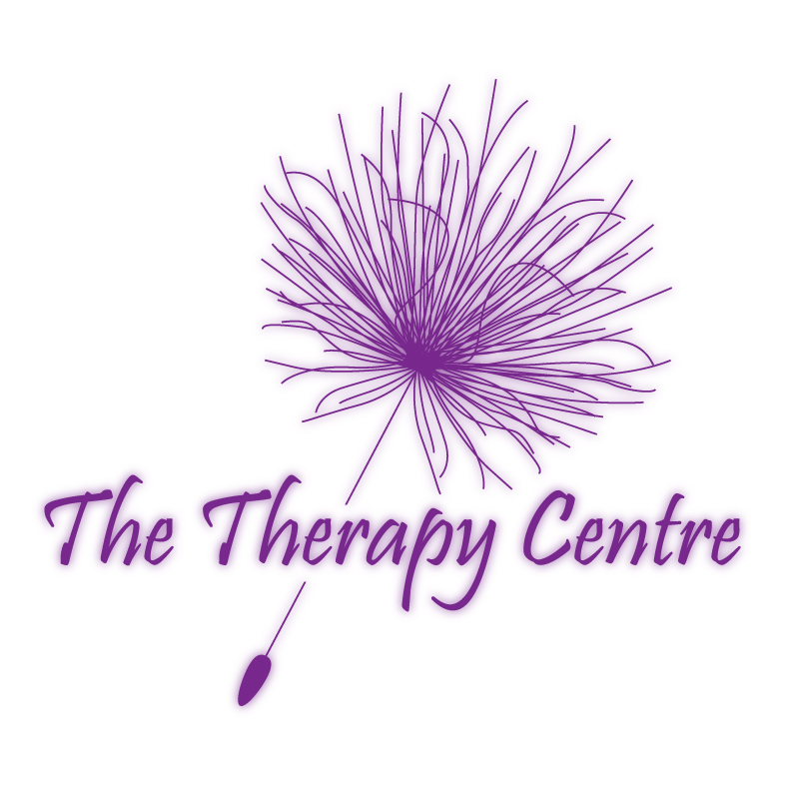
To ensure the course of your selection meets your needs, and that places are still available,
please contact the trainer or facilitator for further information.

Course Title: | REIKI Il
Introduction: | Reiki is a powerful method of hands on healing and self-development that is easily learnt. It differs from other methods of healing in that it requires a series of attunements by a Reiki Master. You will be given a comprehensive manual on completion of your two days training.
Requirements: | Reiki l
Benefits: | This course introduces the use of sacred symbols for healing and spiritual development, methods of distant healing, ethical conduct and four further attunements. Case studies are an integral part of Reiki ll to support learning and understanding. Following this training you can obtain insurance to provide Reiki to the general public as a healing tool.
Syllabus: | - Cho Ku Rei – The Power Symbol  - Sei He Ki – Mental / Emotional Symbol  - Hon Sha Ze Sho Nen – The Distance Symbol  - Goal Setting  - Distant Healing  - Group Healing  - Guidelines For Being A Practitioner |  | - Reiki and Energy Exchanges  - Ethics of Reiki  - How Will I Present Myself To My Clients ?  - How Will I Offer My Services To My Clients ?  - Advertising  - Case Studies  - Insurance
Certification: | Certificate of Attendance – Valid for insurance purposes.
Duration: | 2 x Days
Group Size: | Maximum of 12 learners per course.
Venue: | The Therapy Centre UK Limited  102 Horsforth Avenue, Bridlington, East Yorkshire YO15 3DF
Trainer: | Lesley Cox – Reiki Master Teacher since June 1999, having trained for her masters with her teacher Sally Mynavati Sudevan from India whose mentor was Sai Baba.  Lesley is an experienced and qualified teacher possessing qualifications in Postgraduate Certificate In Education, BA (Hons) Applied Social Science and Business, Anatomy and Physiology, Diploma in Counselling, Reflexology, Touch For Health, Emotional Freedom Therapy, Hopi Ear Candles, Thai Hand and Foot Massage, Body Massage and Indian Head Massage.
Payment: | Non-returnable deposit of £35 is required to ensure you a place on the course.  Payment to be paid in full four weeks prior to course date.
2018 Reiki ll Schedule

Dates |  | Times |  | Cost
Saturday 16th & Sunday 17th June 18 |  | 9.30 a.m. – 5.30 p.m. |  | £125.00
Recommendations: | Reiki III Master Teacher Level

