The Therapy Centre UK Limited  102 Horsforth Avenue, Bridlington, East Yorkshire YO15 3DF  Tel/Fax: 01262 674801  Email: info@therapycentreuk.com  Website: www.therapycentreuk.com  REIKI I TRAINING |  |  |  |  |  | 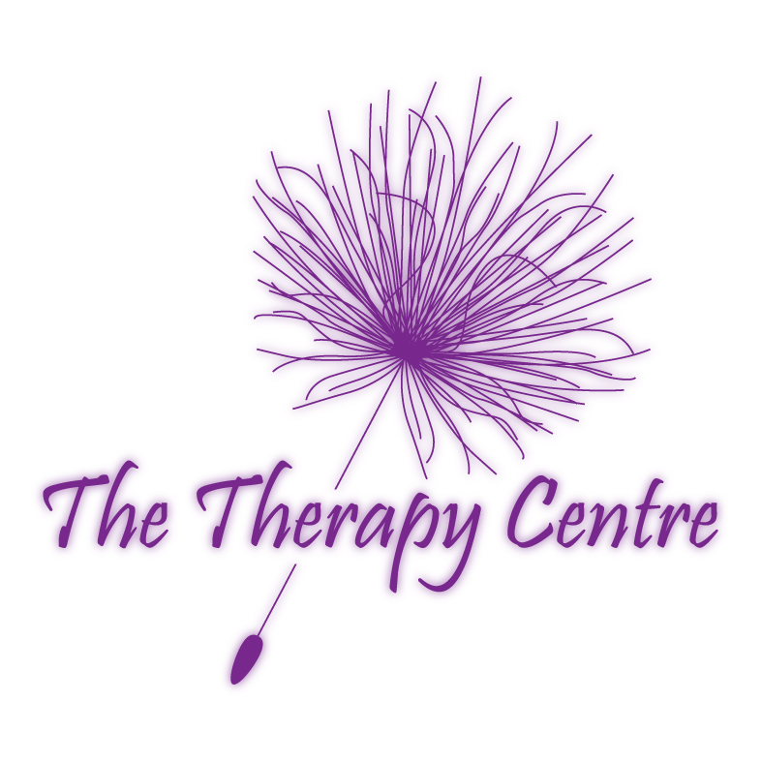
To ensure the course of your selection meets your needs, and that places are still available,
please contact the trainer or facilitator for further information.

Course Title: | REIKI I
Introduction: | Reiki is a powerful method of hands on healing and self-development that is easily learnt. It differs from other methods of healing in that it requires a series of attunements by a Reiki Master. You will be given a comprehensive manual on completion of your two days training.
Requirements: | None
Benefits: | This course emphasises its use for personal empowerment and spiritual growth, with guided visualisation, meditation and four individual attunements.  Following this training you can use it on yourself, family, friends and animals.
Syllabus: | - What is Reiki?  - The Story of Reiki / Additional History  - The Five Reiki Principles  - 21 Day Clearing Cycle  - The 12 Reiki Hand Positions  - Additional Hand Positions  - Treating Others |  | - Basic Body Anatomy  - Chakra Awareness Guide  - Chakra Colour Qualities  - Short Treatment Method  - Self Treatment  - Rules for Being Human  - Book List
Certification: | Certificate of Attendance – Valid for insurance purposes.
Duration: | 2 x Days
Group Size: | Maximum of 12 learners per course.
Venue: | The Therapy Centre UK Limited  102 Horsforth Avenue, Bridlington, East Yorkshire YO15 3DF
Trainer: | Lesley Cox – Reiki Master Teacher since June 1999, having trained for her masters with her teacher Sally Mynavati Sudevan from India whose mentor was Sai Baba.  Lesley is an experienced and qualified teacher possessing qualifications in Postgraduate Certificate In Education, BA (Hons) Applied Social Science and Business, Anatomy and Physiology, Diploma in Counselling, Reflexology, Touch For Health, Emotional Freedom Therapy, Hopi Ear Candles, Thai Hand and Foot Massage, Body Massage and Indian Head Massage.
Payment: | Non-returnable deposit of £35 is required to ensure you a place on the course.  Payment to be paid in full four weeks prior to course date.
2023 Reiki l Schedule

Dates |  | Times |  |  | Cost
Saturday 28th & Sunday 29th^{th} Oct 2023 |  | 9.30 a.m. – 5.30 p.m. |  |  | £125.00
Recommendations: | Reiki II Practitioner Level |  |  | Reiki III Master Teacher Level

