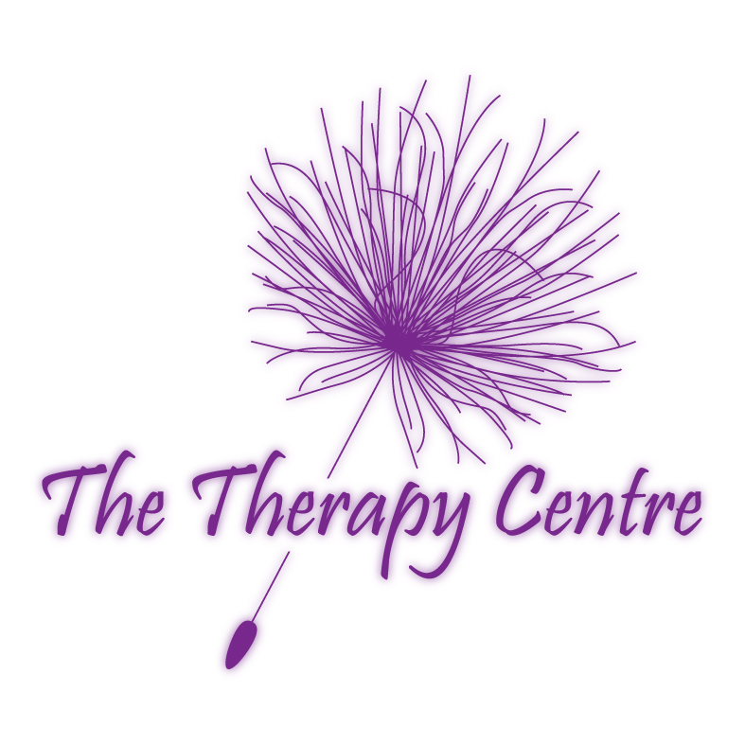
The Therapy Centre UK Limited

SPECIAL EVENT – AMAZING PRICES

FRIDAY 27TH MARCH 2020

Normal prices are shown based on 50 minutes of treatment time

Please tick box if
treatment requested
Hot Stone Massage with Lesley Cox
Hot stone massage uses the heat from the stones to complement the massage techniques used. The warmth of the hot stones improves circulation and calms the nervous system. It is said that one movement with the stone is equal to ten movements of traditional massage.
SALE £25.00
Back and neck 50 minutes ….....................................................Normal price £35.00.......... 

Indian Head Massage with Sarah Walker and Lesley Cox
Massage is given to scalp, face, neck and shoulders. This technique aids relaxation, stress reduction, joint mobility, toxin elimination, improves circulation, promotes hair growth, helps relieve eye strain, tinnitis, jaw ache, sinus congestion, neck and shoulder aches and stiffness and insomnia, calms, improves mental alertness and concentration and many more.
SALE £25.00
50 minutes ..................................................................................Normal price £35.00..........  

Swedish Massage with Sarah Walker or Lesley Cox
Swedish massage is the best-known type of massage. It uses firm but gentle movements to improve circulation, decrease muscle tension, improve flexibility, promotes deep relaxation, decrease anxiety, improve quality of sleep, relieve stress and tension, improve lymphatic drainage, remove toxins and many more.
Swedish back and neck massage 50 minutes......................................................................... 
SALE £25.00

Or Swedish leg and arm massage 50 minutes............................Normal price £35.00.......... 
Or full body Swedish massage 50 minutes............................................................................ 

Reflexology with Sarah Walker or Lesley Cox
A specific pressure technique applied to all areas of the feet. In the feet are reflex points that relate to all parts of the body. By working the reflex points a reflexologist can determine areas within the body that are out of balance and correct them.
SALE £25.00
50 minutes ................................................................…............... Normal price £35.00....………

Aromatherapy with Sarah Walker
Aromatherapy combines the healing properties of organic essences of aromatic plants with the therapeutic values of massage.
Aromatherapy back and neck massage 50 minutes............................................................... 
SALE £25.00
Or aromatherapy leg and arm massage 50 minutes................... Normal price £35.00.......... 

Or full body aromatherapy massage 50 minutes..............................................................…..

Thai Hand and Foot Massage with Lesley Cox
Thai massage is also known as “Thai Bodywork”. Thai massage involves the rhythmic compression of energy lines and points. Following a treatment you will usually feel more open, stretched, refreshed and balanced. It has a calming and healing effect, relieving excess energy and increasing positive energy flow.
SALE £25.00
50 minutes ..............................................……….............….... Normal price £35.00....…...
© The Therapy Centre 02.01.20

Reiki with Lesley Cox
Reiki means “Universal life force “. Its origins can be dated thousands of years back to Tantric Buddhism in Tibet. Reiki is a spiritual method of hands-on healing. It can be used in any situation. Reiki adjusts to the needs of the recipient, promoting balance and wholeness and aids self-development. It does not conflict with other forms of therapy.
SALE £25.00
50 minutes ..................................................................................Normal price £35.00.......... 

Nova Sonic Therapy including Swedish Massage with Sarah Walker
Nova sonic therapy creates sounds waves to the treatment area. The sound waves can penetrate up to
2 ¼” within the body, treating areas inaccessible to conventional manipulative techniques. Nova sonic therapy also helps in rheumatic and arthritic conditions, sciatica, backaches, sinus trouble, swelling and sprains, muscle spasms, tension and tennis elbow. In this session, nova sonic is combined with Swedish massage to enhance the relief of stress and tension, improve circulation and removal of toxins.
SALE £25.00
Nova sonic therapy & Swedish back & neck massage 50minutes...... Normal price £35.00…..
Or nova sonic therapy & Swedish leg and arm massage 50 minutes…………................…..…

Hopi Ear Candle With Reiki with Lesley Cox
Hopi means “peaceful people, people of place”. Hopi ear candles are truly natural and are hand made from a traditional recipe. Ear candles are traditionally used to cleanse and harmonise the different energy fields in the individual’s aura and to drive out negative energies. Hopi ear candles can also be used for many problems related to the head and ear area.
SALE £25.00
50 minutes ……………………………….................................. Normal price £35.00.......…….

Emotional Freedom Therapy (EFT) with Alan Burbanks
SALE £25.00
Balancing emotions through a combination of energy pressure points and counselling techniques.
© The Terapy Centre 09.02.05
50 minutes.....................................................................................Normal price £35.00.….……..

Neuro-Linguistic Programming With/Without Hypnosis with Alan Burbanks
Transform your emotional state, thought processes and unwanted behaviours with these techniques.
© The Terapy Centre 09.02.05
SALE £35.00
Sessions can be used to raise confidence or eradicate fears and phobias.
50 minutes.....................................................................................Normal price £55.00.….……..

Clinical Hypnotherapy with Alan Burbanks
Hypnotherapy is a combination of hypnosis and therapeutic intervention. The therapist leads
the client to positive change while the client is deeply relaxed in a state of heightened
SALE £35.00

suggestibility called trance.
50 minutes.....................................................................................Normal price £55.00.….……..

Smoking Cessation with Alan Burbanks
SALE £25.00
Stop smoking with guidance from a certified Smoking Cessation Advisor.
© The Terapy Centre 09.02.05
50 minutes.....................................................................................Normal price £35.00.….……..

Relaxation and Meditation with Lesley Cox
During the session you will use your senses and be guided to a place of warmth, comfort and inner beauty where answers can be readily found. Traditional breathing techniques, progressive muscular relaxation, visual imagery and positive reinforcement will all be taught in order to reduce stress levels and bring about well-being of the whole person.
SALE £25.00
50 minutes.............................................…........Normally service is offered in a group format…..

Relaxing Facial with Sarah Walker
A relaxing facial involving a facial cleanse, tone, mask, massage and moisturise. Aromatherapy oils are utilised in the massage, if desired, to further promote relaxation via their healing properties and beautiful aromas.
SALE £25.00
50 minutes.....................................................................................Normal price £30.00.….……..

Paraffin Wax Facial with Sarah Walker
Paraffin wax combined with a mini facial treatment to enhance texture and appearance. This treatment is good for dry skin as it helps to moisturise. The paraffin wax is applied to the face warm and then peeled off when cool.
SALE £25.00
50 minutes.....................................................................................Normal price £30.00.….……..

Paraffin Wax For Specific Ailments with Sarah Walker
Paraffin wax can be applied to the hands, feet, knees and other areas. This may be combined with other beauty treatments such as manicures and pedicures. Paraffin wax is an excellent medium to aid relief in arthritic conditions and joint stiffness.
SALE £25.00
50 minutes.....................................................................................Normal price £35.00.….……..

For prices and terms and conditions please see Booking Form on reverse

- No refunds will be made for cancellations or non-attendance.
- Appointments are available between 9am and 5pm at 1 hourly intervals.
- Appointments are allocated on a first come first served basis.
…………………………………………………………………………………………………………..
ONE FORM PER PERSON
Please state if you have a time preference and we will oblige if possible.
………………………………........................................................................................................................
………………………………........................................................................................................................
NAME:……………………………...............................................................................................................
ADDRESS:……………………………........................................................................................................
………………………………........................................................................................................................
………………………………........................................................................................................................
TEL:……………………………...................................................................................................................
Please submit payment with form. Cheques made payable to The Therapy Centre UK Limited
Amount enclosed:£……………………………….…………………………………………………..…..
Signature:……………………….....………………..........…………………………………………………
The Therapy Centre UK Limited
102 Horsforth Avenue, Bridlington, East Yorkshire YO15 3DF
Tel/Fax Number 01262 674801
Email: info@therapycentreuk.com
Website: www.therapycentreuk.com
…………………………………………………………………………………………………………..

