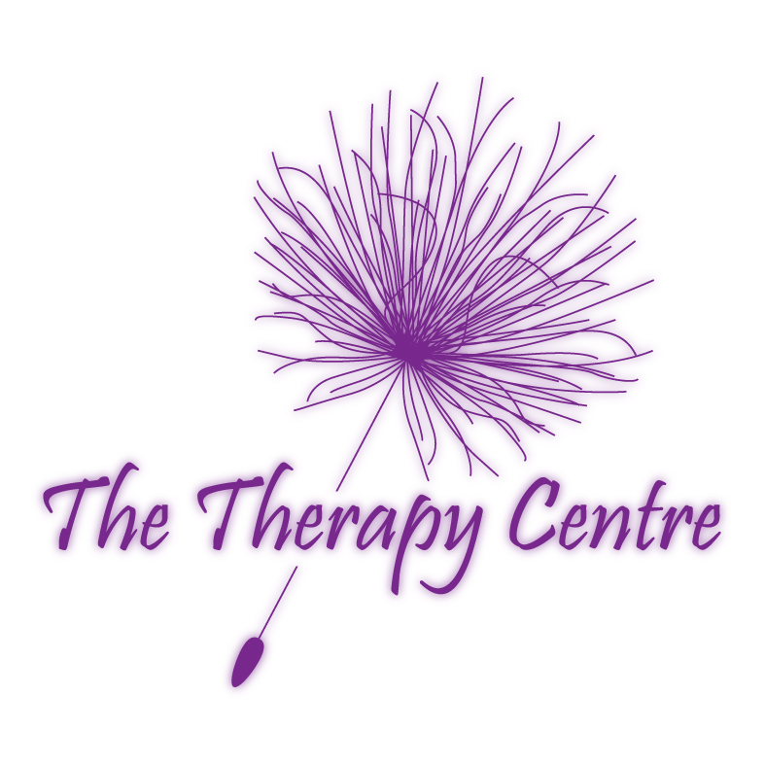
The Therapy Centre UK Limited

PAMPER DAY

FRIDAY 31ST JANUARY 2020

TASTER SESSION BOOKING FORM

Please tick box if
treatment requested
Hot Stone Massage with Lesley Cox
Hot stone massage uses the heat from the stones to complement the massage techniques used. The warmth of the hot stones improves circulation and calms the nervous system. It is said that one movement with the stone is equal to ten movements of traditional massage.
1 hour …................................................................................................................................ 

Indian Head Massage with Sarah Walker or Lesley Cox
Massage is given to scalp, face, neck and shoulders. This technique aids relaxation, stress reduction, joint mobility, toxin elimination, improves circulation, promotes hair growth, helps relieve eye strain, tinnitis, jaw ache, sinus congestion, neck and shoulder aches and stiffness and insomnia, calms, improves mental alertness and concentration and many more.
30 minutes ............................................................................................................................. 

Reiki with Lesley Cox
Reiki means “ Universal life force “. Its origins can be dated thousands of years back to Tantric Buddhism in Tibet. Reiki is a spiritual method of hands-on healing. It can be used in any situation. Reiki adjusts to the needs of the recipient, promoting balance and wholeness and aids self-development. It does not conflict with other forms of therapy.
30 minutes ............................................................................................................................. 

Swedish Massage with Sarah Walker or Lesley Cox
Swedish massage is the best-known type of massage. It uses firm but gentle movements to improve circulation, decrease muscle tension, improve flexibility, promotes deep relaxation, decrease anxiety, improve quality of sleep, relieve stress and tension, improve lymphatic drainage, remove toxins and many more.
Swedish back massage30 minutes ........................................................................................ 
Swedish leg massages 30 minutes ........................................................................................ 
Swedish arm massage 30 minutes ......................................................................................... 
Full body Swedish massage 1 hour........................................................................................ 

Aromatherapy with Sarah Walker
Aromatherapy combines the healing properties of organic essences of aromatic plants with the therapeutic values of massage.
Foot OR Hand 30 minutes .................................................................................................... 
Leg OR Arm 30 minutes ....................................................................................................... 
Back 30 minutes .................................................................................................................... 
Neck 30 minutes ................................................................................................................... 

© The Therapy Centre 02.01.20

Emotional Freedom Therapy (EFT) with Alan Burbanks or Lesley Cox

Balancing emotions through a combination of energy pressure points and counselling techniques.
© The Terapy Centre 09.02.05
1 hour ...................................................................................…………………………..….……..

Neuro-Linguistic Programming With/Without Hypnosis with Alan Burbanks
Transform your emotional state, thought processes and unwanted behaviours with these techniques.
© The Terapy Centre 09.02.05

Sessions can be used to raise confidence or eradicate fears and phobias.
1 hour……...................................................................................……………………...….……..

Clinical Hypnotherapy with Alan Burbanks
Hypnotherapy is a combination of hypnosis and therapeutic intervention. The therapist leads the client to positive change while the client is deeply relaxed in a state of heightened suggestibility called trance.
1 hour……...................................................................................……………………...….……..

Nova Sonic Therapy including Swedish Massage with Sarah Walker
Nova sonic therapy creates sounds waves to the treatment area. The sound waves can penetrate up to
2 ¼” within the body, treating areas inaccessible to conventional manipulative techniques. Nova sonic therapy also helps in rheumatic and arthritic conditions, sciatica, backaches, sinus trouble, swelling and sprains, muscle spasms, tension and tennis elbow. In this session, nova sonic is combined with Swedish massage to enhance the relief of stress and tension, improve circulation and removal of toxins.
Nova sonic therapy & Swedish back & neck massage 30minutes............................................…
Nova sonic therapy & Swedish leg massage 30 minutes. ……………………........................…

Nova sonic therapy & Swedish arm massage 30 minutes ………………………………........…

Thai Hand Or Foot Massage with Lesley Cox
Thai massage is also known as “Thai Bodywork”. Thai massage involves the rhythmic compression of energy lines and points. Following a treatment you will usually feel more open, stretched, refreshed and balanced. It has a calming and healing effect, relieving excess energy and increasing positive energy flow.
30 minutes ..............................................……….................................................................…….

Hopi Ear Candle With Reiki with Lesley Cox
Hopi means “peaceful people, people of place”. Hopi ear candles are truly natural and are hand made from a traditional recipe. Ear candles are traditionally used to cleanse and harmonise the different energy fields in the individual’s aura and to drive out negative energies. Hopi ear candles can also be used for many problems related to the head and ear area.
1 hour ……………………………………..............................................................……..............

Reflexology with Sarah Walker or Lesley Cox
A specific pressure technique applied to all areas of the feet. In the feet are reflex points that relate to all parts of the body. By working the reflex points a reflexologist can determine areas within the body that are out of balance and correct them.
30 minutes ................................................................….....................................................………

Manicure (Nail and hand treatment) with Sarah Walker
File, buff, cuticle treatment, massage OR polish.
30 minutes ……………………………….............................................……................................

Pedicure (Nail and foot treatment) with Sarah Walker
File, buff, cuticle treatment, massage OR polish.
30 minutes ………………………………..................................................……...........................

Eyebrow Shape with Sarah Walker
Defining of natural eyebrow shape using the tweezer method to enhance facial features.
30 minutes ………………………………......................................................…….......................

Mini Facial with Sarah Walker
Cleanse, tone and moisturise, as well as mask OR massage.
30 minutes ……………………………….........................................................……....................

Relaxing Facial with Sarah Walker
A relaxing facial involving a facial cleanse, tone, mask, massage and moisturise. Aromatherapy oils are utilised in the massage, if desired, to further promote relaxation via their healing properties and beautiful aromas.
1 hour …………………………………….....................................................................……......

Paraffin Wax Facial with Sarah Walker
Paraffin wax combined with a mini facial treatment to enhance texture and appearance. This treatment is good for dry skin as it helps to moisturise. The paraffin wax is applied to the face warm and then peeled off when cool.
1 hour ……………………………………...........................................................……................

Paraffin Wax For Specific Ailments with Sarah Walker
Paraffin wax can be applied to the hands, feet, knees and other areas. This may be combined with other beauty treatments such as manicures and pedicures. Paraffin wax is an excellent medium to aid relief in arthritic conditions and joint stiffness.
1 hour ……………………………………................................................................……...........

PLEASE COMPLETE BOOKING FORM ON REVERSE OF PAPER

COST OF TREATMENTS

1 Half hour…………………………………………………………………...£16.00 per half hour

2 Half hours………………………………………………………………….£14.00 per half hour

3 Half hours or more..……………………………………………………….£12.00 per half hour
- Please make payments in advance of Pamper Day.
- No refunds will be made for cancellations or non-attendance.
- Appointments are available between 9am and 5pm at ½ hourly intervals.
- Appointments are allocated on a first come first served basis.
…………………………………………………………………………………………………………..
ONE FORM PER PERSON
Please state if you have a time preference and we will oblige if possible.
………………………………........................................................................................................................
NAME:……………………………...............................................................................................................
ADDRESS:……………………………........................................................................................................
TEL:……………………………...................................................................................................................
Please submit payment with form. Cheques made payable to The Therapy Centre UK Limited
Amount enclosed:£………………………………. Signature:.....................…………................................
The Therapy Centre UK Limited
102 Horsforth Avenue, Bridlington, East Yorkshire YO15 3DF
Tel/Fax Number 01262 674801
Email: info@therapycentreuk.com
Website: www.therapycentreuk.com

