The Therapy Centre UK Limited  102 Horsforth Avenue, Bridlington, East Yorkshire YO15 3DF  Tel/Fax: 01262 674801  Email: info@therapycentreuk.com  Website: www.therapycentreuk.com  PERSONAL & SPIRITUAL DEVELOPMENT |  |  |  |  |  | 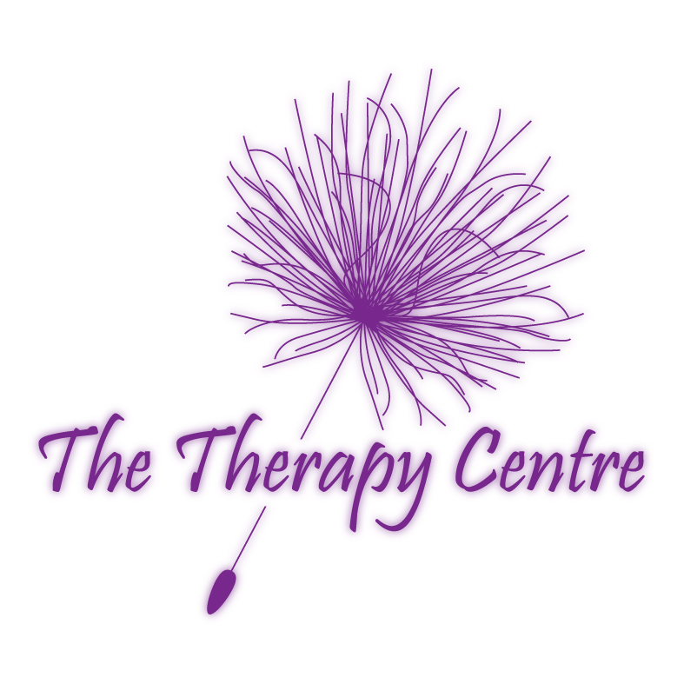
To ensure the course of your selection meets your needs and that places are still available,
please contact the trainer or facilitator for further information.

Course Title: | Personal & Spiritual Development
Introduction: | An experiential learning group providing opportunities to improve the quality of ones life by heightening the senses and raising self-expression to enable interaction with individuals, society and the universe on all levels of being.
Requirements: | This is an intense group and an informal interview with facilitators is a requirement to ensure the group is appropriate to meet your needs.
Benefits: | - Self-awareness  - Positive mental attitude  - Being empowered  - Raising expectations  - Learning to receive  - Being fulfilled |  | - Raising personal responsibility  - Finding ones purpose  - Following your dream  - Taking charge of your direction in life |  | - Interaction with spiritual guides and realms  - Developing psychic abilities  - Understanding the bigger picture
Certification: | N/A
Duration: | 2 hours per session
Group Size: | Maximum of 14 group members plus 2 facilitators
Venue: | The Therapy Centre UK Limited  102 Horsforth Avenue, Bridlington, East Yorkshire YO15 3DF
Facilitators: | Jo Stephenson – Multi-qualified therapist, nurse, teacher and manager.  Sarah Walton – Multi-qualified therapist, teacher, assessor and manager.
Payment: | Non-returnable deposit of £20 is required to ensure you a place on the course.  Payment to be paid in full four weeks prior to course date.
2018 Personal & Spiritual Development Schedule

Themes |  | Dates |  | Times |  |  | Cost
Fresh Start |  | 8th January to 12th February 18 |  | Mondays  9.30 a.m. – 11.30 a.m. |  |  | £60.00
Targets |  | 9th March to 20th April 18  (No Group 30th March 18) |  | Fridays  5.30 p.m. – 7.30 p.m. |  |  | £60.00
Introspection |  | 27th April to 25th May 18 |  | Fridays  5.30 p.m. – 7.30 p.m. |  |  | £50.00
Recommendations: | Attendance at any further Personal & Spiritual Development sessions

